Site Ops Backup/Offsite Storage Facilities Policy & Procedure

# 1 – Overview

The intent of this document is to define and develop a policy for back-up scheduling and offsite storing on CB Site Operations systems. This document will define policies and procedures and should be used as a reference for backing up production and development servers.

# 2 – Purpose

The purpose of creating a policy is to provide general guidelines for Site Operations employees to follow for backup of sensitive data on CB Site Operations systems production systems.

# 3 – Scope

The scope of this policy applies to Site Operations standard procedures.

3.1 – Responsibility

Site Operations is responsible for reviewing and maintaining any changes to this policy. The policy will be reviewed bi-annually for its content and accuracy.

# 4 – Policy

4.1 – General

All tape backups are done using BackupExec. All tapes are encrypted using Dell EKM Library-managed Encryption, which uses an algorithm that is a National Institute of Standards and Technology (NIST) approved AES-256 block cipher.

* All tapes at QTS are kept in the tape library in SiteOps suite.
* All tapes at Office are stored in a locked cabinet – keys held by Mahmoud and all SiteBackend team members. Cabinet is in a room accessible only to SiteOps team.
* Daily Backup:
  + Database volumes are synced to middle tier SAN environment.
  + Each day a crash consistent virtual copy is made of each database volume in middle tier SAN environment.
  + Each hour each middle tier database volume is replicated to DR SAN environment.
  + Each day each middle tier database is refreshed every morning to DR SAN environment.
  + Each day for web tier Control and DSRV databases, a crash consistent virtual copy is made in the web SAN environment.
* Weekly Backup:
  + One week’s worth of daily copies is kept on SAN environment with the oldest being deleted after seven days.
* Monthly Backup:
  + Second Monday and Tuesday of each month:
    - Two sets of backups taken from QTMBKP1 to encrypted tape.
  + Following completion of second set of tape backups:
    - One set of tapes taken from QTS to Office
    - Set one placed in cabinet
    - Set two loaded into DEV environment tape library
    - Test restore to DEV takes place
    - Set two tapes taken to cabinet at Office
  + Fourth Monday of each month:
    - Both sets of tapes picked up by Recall
    - Set one shipped to Atlanta Recall facility

6111 Live Oak Parkway, Norcross, GA 30093

* + - Set two shipped to Chicago Recall facility

880 East Stat Parkway, Schaumburg, IL 60173

4.2 – Tape retrieval

* + All requests for retrieval of tapes from offsite storage access should be accompanied by a TeamTrack ticket. This must be approved by an Authorized Employee before request is submitted to Recall.
  + Authorized Employees are Ali Shahzad, Mahmoud Harb, Colin Field, Mark Fouraker, Jarred Fehr, Kevin Luu, and Gary Dawkins.

4.3 – SiteNetwork Configuration Backups

* All production network devices (except Juniper) are backed up using Solarwinds Network Configuration Management module.
  + Config is backed up E:\Config-Archive on SOLARWINDSAPP.
  + E:\Config-Archive Folder gets backed up by SiteBackend.
  + Configs are purged every 3 weeks.
* Juniper and Silverpeak GMS are backed up from the SAG boxes to SOLARWINDSAPP over SFTP.
  + Config is backed up to E:\sftproot\.
  + E:\SFTP_Root folder gets backed up by Site Backend.
  + Configs are purged every 3 weeks.

# 5 – Access

* Authorized employees may contact the Recall C.A.R.E Center to retrieve tapes from offsite storage. Phone: 1-866-RECALL8 (1-866-732-2558)
* Recall offers the following services for tape retrieval:
  + Routine - This is based on the client rotation schedule- either daily, weekly, monthly or bi-monthly.
  + After Hours - After the normal delivery hours of 8-5pm
  + Holidays/Weekends - Recall is able to deliver tapes on holidays and weekends if necessary.
  + Disaster Recovery - Same day delivery within 3 hours of an order being placed if ordered between 8:00 am – 3:00 pm

Current Access Status:

**Atlanta – T192**

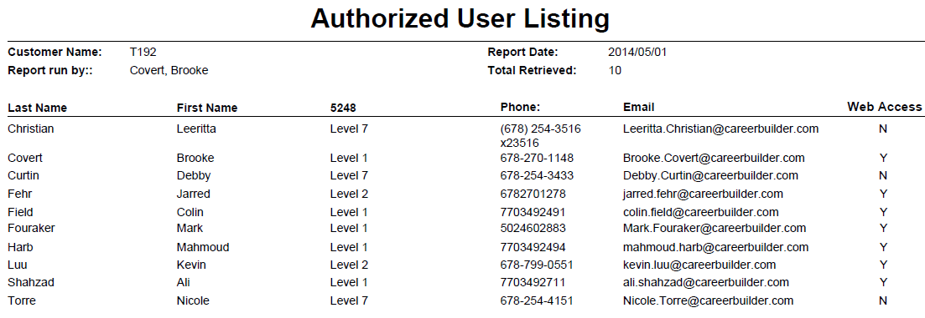

**Chicago – T515**

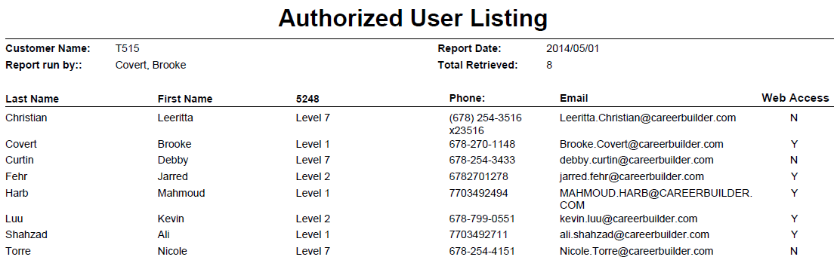

# 6 – Revision History

1.0 06/29/09 Robert Wicks   
1.1 06/29/09 Jon Mason

1.2 06/30/09 Jeff Hitt

1.3 08/01/11 Brooke Covert

1.4 08/31/11 Brooke Covert

1.5 11/16/11 Brooke Covert

1.6 11/17/11 Jarred Fehr

1.7 02/22/12 Brooke Covert

1.8 05/31/12 Brooke Covert

1.9 07/26/12 Brooke Covert Updated Access List

2.0 11/27/12 Jarred Fehr Updated process details

2.0 02/28/13 Brooke Covert Reviewed

2.1 05/22/13 Brooke Covert Reviewed, Updated Access Lists

2.2 07/29/13 Brooke Covert Updated Access List

2.3 08/15/13 Brooke Covert Updated formatting

2.4 02/17/14 Brooke Covert Reviewed, Updated Access Lists, added section 4.3

2.5 05/22/14 Kevin Luu Updated process details, sections 4.1 and 4.3, access lists